Generative AI Laboratory Manual: Fine-Tuning, Prompt Optimization, Evaluation and Bias Mitigation

Lesson 6 — Fine-Tuning Models with Prompts
Incorporating prompts into training and balancing task performance with generalization.
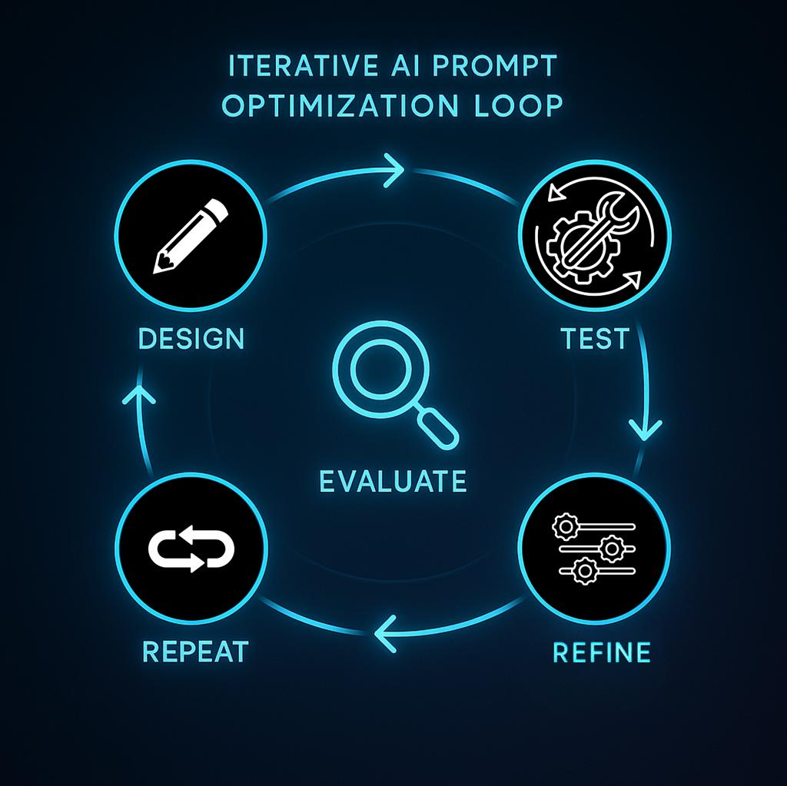
Lesson 7 — Optimizing Prompt Selection
Comparing prompt alternatives and adapting prompts to model behavior.
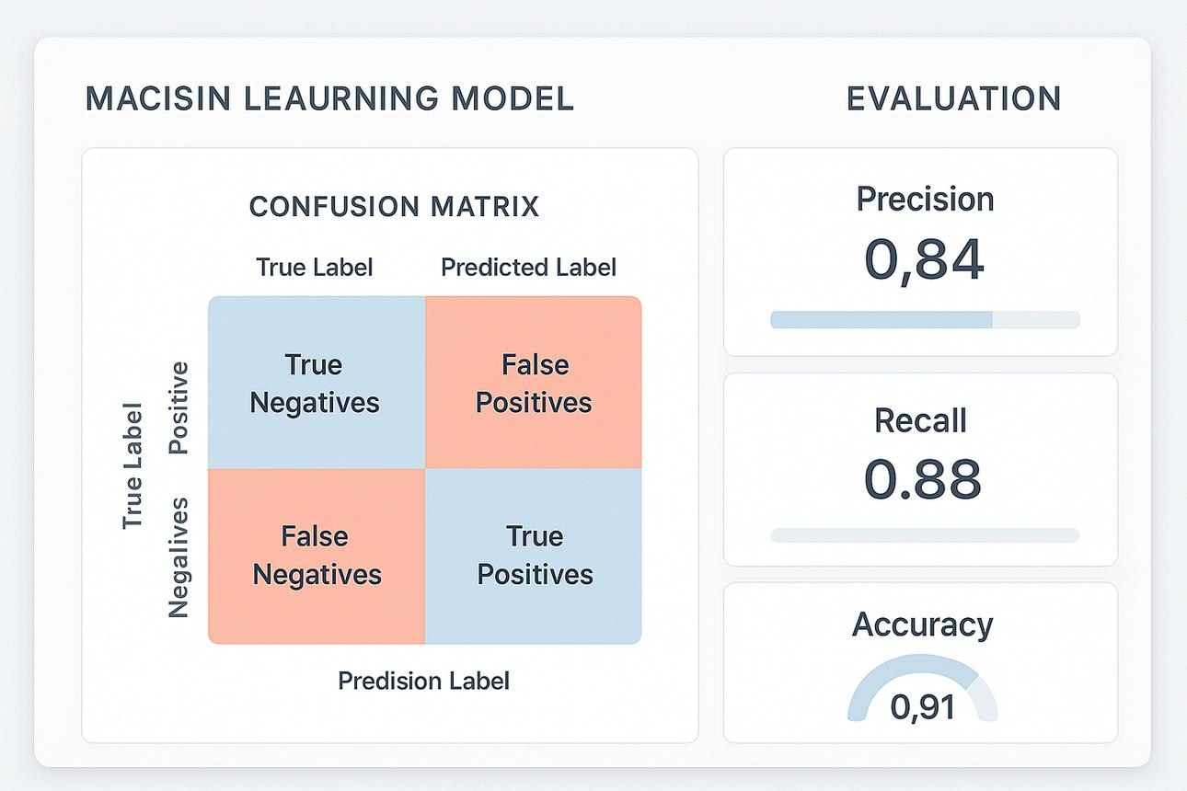
Lesson 8 — Evaluating Prompt Performance
Measuring accuracy, precision, recall, F1-score, robustness, and consistency.
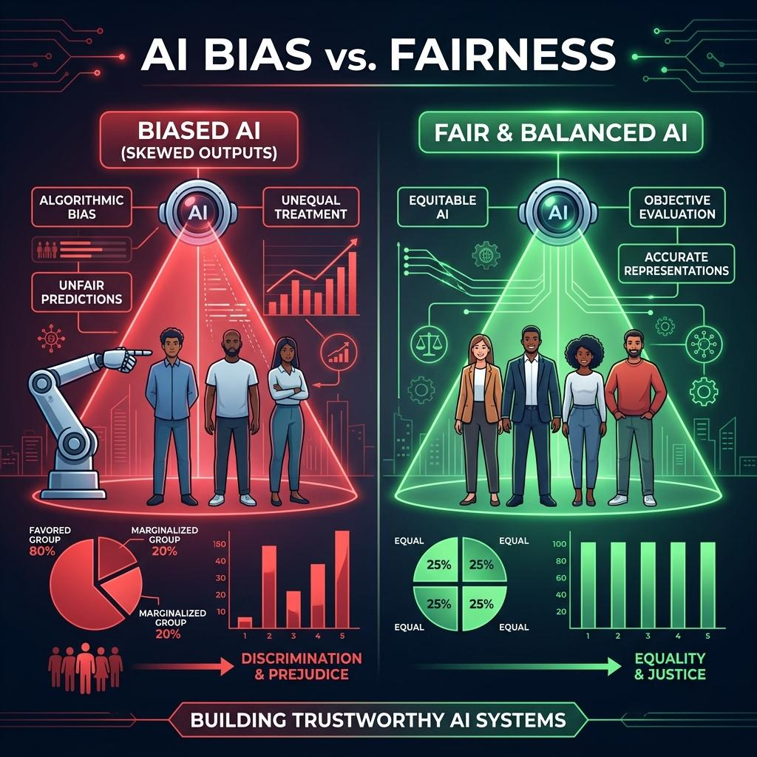
Lesson 9 — Bias Mitigation in Prompt Engineering
Detecting unfair outputs and improving fairness, inclusivity, and consistency.

Common laboratory setup
You can execute these experiments in Google Colab or a local Jupyter Notebook. The first three experiments use sentiment classification as a common example; the fourth uses a synthetic dataset to demonstrate fairness testing.

Step 1: Install the required libraries

!pip install -q transformers datasets peft accelerate \

scikit-learn pandas matplotlib

Step 2: Import common libraries
import numpy as np
import pandas as pd
import torch
from datasets import load_dataset
from transformers import (
AutoTokenizer,
AutoModelForSequenceClassification,
TrainingArguments,
Trainer
)

from sklearn.metrics import (
accuracy_score,
precision_recall_fscore_support,
confusion_matrix,
classification_report
)
Recommended hardware: A computer with 8 GB RAM; a GPU is useful for Transformer fine-tuning. Some experiments can run on CPU, but training may take longer.

Lesson 6 —Fine-Tuning Models with Prompts

1. Aim
To study and implement prompt-based fine-tuning techniques, compare prompt-based training with conventional model fine-tuning, and investigate how prompt design influences model performance and generalization.

2. Theory
Fine-tuning adapts a pre-trained model to a specific task using labeled examples. Prompt-based fine-tuning supplies task instructions or task-specific prompt representations during training.
There are three important approaches.
A. Prompt-based supervised fine-tuning
The training input contains a task instruction along with the original example. Model weights are updated using the labeled data.
Example: Classify the sentiment as positive or negative: This movie is excellent.
B. Soft Prompt Tuning
Learnable virtual token embeddings are added to the input representation. The original Transformer weights are frozen, and only the prompt embeddings are trained.
C. LoRA-based fine-tuning
Low-rank trainable matrices are introduced into selected model layers. The original weights are kept frozen, and the added parameters are trained.
For this experiment, we use prompt-based supervised fine-tuning with DistilBERT. It is easy to run and demonstrates how a task instruction can be included in the training examples. It is important to distinguish this from soft prompt tuning: adding words to the input is not the same as learning virtual prompt embeddings.

3. Algorithm
- Load a labeled sentiment dataset.
- Select training and test samples.
- Load the tokenizer and pre-trained model.
- Add a task instruction to each input.
- Tokenize the prompted examples.
- Train the model using labeled sentiment data.
- Evaluate the model on held-out test examples.
- Test the model on new reviews.
- Compare training and evaluation results.
- Conclude whether the prompt-based model generalizes to unseen examples.

4. Detailed procedure

Step 1: Load the dataset
The IMDB dataset contains positive and negative movie reviews.
from datasets import load_dataset
dataset = load_dataset("imdb")
train_data = (
dataset["train"]
.shuffle(seed=42)
.select(range(2000))
)
test_data = (
dataset["test"]
.shuffle(seed=42)
.select(range(500))
)
print(train_data)
print(test_data)
Why use a subset? It reduces the computation required for a classroom experiment. Results from a small subset may be less reliable than results from a full dataset.

Step 2: Add prompts to the examples
We add the same task instruction to every review.
def add_prompt(example):
return {
"text": (
"Classify the sentiment as positive or negative. "
+ example["text"]
),
"label": example["label"]
}
train_data = train_data.map(add_prompt)
test_data = test_data.map(add_prompt)
For example:
Original review | Prompted input | Label
The movie was wonderful. | Classify sentiment: The movie was wonderful. | Positive (1)
The story was boring. | Classify sentiment: The story was boring. | Negative (0)
The instruction guides the task, while the label supplies the correct answer during supervised training.

Step 3: Load the model
model_name = "distilbert-base-uncased"
tokenizer = AutoTokenizer.from_pretrained(model_name)
model = AutoModelForSequenceClassification.from_pretrained(
model_name,
num_labels=2
)
The classification model returns two scores, one for each class.

Step 4: Tokenize the examples
def tokenize_function(examples):
return tokenizer(
examples["text"],
truncation=True,
padding="max_length",
max_length=128
)
train_data = train_data.map(
tokenize_function,
batched=True
)
test_data = test_data.map(
tokenize_function,
batched=True
)
train_data = train_data.remove_columns(["text"])
test_data = test_data.remove_columns(["text"])
train_data.set_format("torch")
test_data.set_format("torch")
Tokenization converts the text into numerical token IDs and attention masks that the model can process.

Step 5: Define the evaluation function

def compute_metrics(eval_pred):

logits, labels = eval_pred

predictions = np.argmax(logits, axis=-1)

precision, recall, f1, _ = (

precision_recall_fscore_support(

labels,

predictions,

average="binary",

zero_division=0

)

)

return {

"accuracy": accuracy_score(labels, predictions),

"precision": precision,

"recall": recall,

"f1": f1

}

Step 6: Train the model
training_args = TrainingArguments(
output_dir="./lesson6_results",
learning_rate=2e-5,
per_device_train_batch_size=8,
per_device_eval_batch_size=8,
num_train_epochs=2,
eval_strategy="epoch",
save_strategy="no",
report_to="none",
seed=42
)
trainer = Trainer(
model=model,
args=training_args,
train_dataset=train_data,
eval_dataset=test_data,
compute_metrics=compute_metrics
)
trainer.train()Training updates the model parameters using the prompted examples and their labels.

Step 7: Evaluate the model
results = trainer.evaluate()
print(results)

Step 8: Test unseen reviews

from transformers import pipeline

classifier = pipeline(

"text-classification",

model=model,

tokenizer=tokenizer

)

reviews = [

"Classify the sentiment: This movie was fantastic.",

"Classify the sentiment: The acting was terrible."

]

for review in reviews:

print(review)

print(classifier(review, truncation=True))

5. Understanding prompt influence and generalization
A prompt can make the task clearer, but a prompt alone does not guarantee better performance. To test the influence of prompts:
- Train with the instruction consistently included.
- Evaluate on a separate set of reviews.
- Test equivalent instructions that preserve the task meaning.
- Check whether accuracy changes substantially when the wording changes.
- Avoid using test examples during training.
Generalization means performing well on examples that were not used for training. A model that memorizes the training set but performs poorly on new examples has weak generalization.

6. Sample output
Illustrative format:
Training completed.

Evaluation:
Accuracy : 0.88
Precision : 0.89
Recall : 0.87
F1-score : 0.88

Input: This movie was fantastic.
Prediction: Positive

Input: The acting was terrible.
Prediction: Negative
These values are examples of output formatting, not guaranteed results.

7. Observation table
S.No. | Parameter | Observation
1 | Model | DistilBERT
2 | Dataset | IMDB
3 | Training samples | 2,000
4 | Test samples | 500
5 | Prompt type | Text instruction
6 | Training epochs | 2
7 | Test accuracy | Record actual value
8 | Generalization | Test with unseen reviews

8. Result
Prompt-based supervised fine-tuning was implemented by adding a task instruction to the training examples. The model was trained on labeled reviews and evaluated on unseen reviews to assess task performance and generalization.

Lesson 7 —Optimizing Prompt Selection

1. Aim
To identify effective prompts for a given task by comparing alternative prompt templates, evaluating model outputs, and selecting the prompt that achieves the best performance on validation data.

2. Theory
Prompt optimization is the process of finding instructions that consistently guide a model toward accurate, relevant, and task-appropriate outputs.
Different prompts can produce different results even when the underlying task and model are unchanged.
Consider sentiment classification:
Prompt ID | Prompt template
P1 | Classify the sentiment of this review.
P2 | Determine whether this review is positive or negative. Return only the label.
P3 | Analyze the review and assign exactly one label: positive or negative.
The prompts have similar meanings, but they differ in clarity, length, and output constraints.

Methods for optimizing prompt selection
1. Manual prompt selection
A person writes several candidate prompts and tests each on the same validation examples.
2. Metric-based selection
Select the prompt with the best validation accuracy, F1-score, or another task-appropriate metric.
3. Iterative optimization
Examine incorrect outputs, improve the wording or output format, and repeat the evaluation.
4. Few-shot prompt selection
Compare prompts that include a small number of correctly labeled examples with prompts containing instructions alone.

3. Algorithm
- Load a labeled dataset.
- Divide it into training, validation, and test sets.
- Prepare several candidate prompt templates.
- Apply every candidate prompt to the same validation examples.
- Obtain model predictions for each candidate.
- Calculate accuracy, precision, recall, and F1-score.
- Compare the candidate prompts.
- Select the prompt with the best validation performance, considering other constraints such as fairness and output consistency.
- Evaluate the selected prompt on the untouched test set.
- Record the results.

4. Detailed procedure
This experiment uses a pre-trained sentiment classifier. Since the objective is prompt selection rather than model training, we can compare prompts quickly without fine-tuning.

Step 1: Load the model and dataset
from datasets import load_dataset
from transformers import pipeline
import numpy as np
import pandas as pd
dataset = load_dataset("imdb")
validation_data = (
dataset["test"]
.shuffle(seed=42)
.select(range(200))
)
test_data = (
dataset["test"]
.shuffle(seed=123)
.select(range(500, 700))
)
classifier = pipeline(
"text-classification",
model="distilbert/distilbert-base-uncased-finetuned-sst-2-english"
)
This example uses a model already fine-tuned for sentiment classification. It is not a generative instruction-following model, so the wording may have less effect than it would on an instruction-tuned LLM. The experiment still demonstrates candidate evaluation and selection; a generative LLM can be substituted for a direct study of instruction wording.

Step 2: Define candidate prompts
prompts = {
"P1": "Review: {text}",
"P2": "Sentiment analysis of this review: {text}",
"P3": (
"Read this movie review and determine "
"its sentiment: {text}"
)
}
Here, {text} is replaced with each movie review.

Step 3: Write a prompt evaluation function
The classifier predicts a label for the prompted text. We map its output to the dataset's positive/negative labels.

from sklearn.metrics import accuracy_score, f1_score

def evaluate_prompt(prompt_template, data):

true_labels = []

predicted_labels = []

for example in data:

text = example["text"][:1500]

prompt = prompt_template.format(text=text)

result = classifier(

prompt,

truncation=True,

max_length=512

)[0]

label = result["label"].upper()

prediction = 1 if label == "POSITIVE" else 0

true_labels.append(example["label"])

predicted_labels.append(prediction)

return {

"accuracy": accuracy_score(

true_labels, predicted_labels

),

"f1": f1_score(

true_labels, predicted_labels

)

}

Step 4: Compare the prompts

results = []

for prompt_id, template in prompts.items():

metrics = evaluate_prompt(

template,

validation_data

)

results.append({

"Prompt": prompt_id,

"Template": template,

"Accuracy": metrics["accuracy"],

"F1-score": metrics["f1"]

})

results_df = pd.DataFrame(results)

print(

results_df.sort_values(

"F1-score",

ascending=False

).to_string(index=False)

)

Step 5: Select the best prompt
best_prompt_id = (
results_df
.sort_values("F1-score", ascending=False)
.iloc[0]["Prompt"]
)
best_prompt = prompts[best_prompt_id]
print("Selected Prompt:", best_prompt_id)
print("Template:", best_prompt)
This selects the candidate with the highest validation F1-score.

Step 6: Test the selected prompt
Use the selected prompt on a separate test set:
test_metrics = evaluate_prompt(best_prompt, test_data)
print("Final Test Results:", test_metrics)
Do not repeatedly modify prompts based on the test results. Doing so would make the test set part of the optimization process and produce an overly optimistic estimate of performance.

5. Customizing prompts based on model behavior
Suppose a model frequently returns explanations when the application requires only a sentiment label. You could modify the instruction:
Initial prompt:
Analyze the review and determine its sentiment.
Revised prompt:
Classify the review as positive or negative.
Return exactly one label, with no explanation.
For generative models, you can also adjust:
- Output format constraints
- Examples in the prompt
- Definition of the task
- Instructions for handling ambiguous inputs
- Requirements for uncertainty or abstention
Always verify whether the revised prompt improves measured performance instead of assuming that a more detailed prompt is better.

6. Sample output
Illustrative output:
Prompt | Validation accuracy | Validation F1
P1 | 0.84 | 0.84
P2 | 0.86 | 0.86
P3 | 0.85 | 0.85
Selected Prompt: P2
Template: Sentiment analysis of this review: {text}
These figures are examples only. Actual results depend on the model, dataset, and prompts.

7. Observation table
S.No. | Observation | Value
1 | Number of candidate prompts | 3
2 | Validation samples | 200
3 | Selection metric | F1-score
4 | Best prompt | Record actual value
5 | Best validation F1 | Record actual value
6 | Final test accuracy | Record actual value
7 | Output consistency | Record observations

8. Result
Several prompt templates were compared using validation metrics. The best-performing candidate was selected and evaluated on separate test data. The experiment demonstrates how systematic prompt evaluation is more reliable than selecting prompts based only on intuition.

Module V — Evaluation and Bias Mitigation

Lesson 8 —Evaluating Prompt Performance

1. Aim
To evaluate a prompt-based classification system using accuracy, precision, recall, F1-score, confusion matrix, and qualitative error analysis, and to interpret the results to identify strengths and weaknesses.

2. Theory
Evaluation determines whether a prompt-based system performs its intended task accurately, consistently, and reliably.
A prompt that generates fluent responses is not necessarily correct. Evaluation requires comparing model outputs with reference labels or answers.

Evaluation metrics
For binary classification, the model's predictions can be categorized into four groups:
- True Positive (TP): Positive example correctly predicted as positive.
- True Negative (TN): Negative example correctly predicted as negative.
- False Positive (FP): Negative example incorrectly predicted as positive.
- False Negative (FN): Positive example incorrectly predicted as negative.

Confusion matrix
Example: sentiment classification
 | Predicted positive | Predicted negative
Actual positive | 40  True Positive | 10  False Negative
Actual negative | 5  False Positive | 45  True Negative

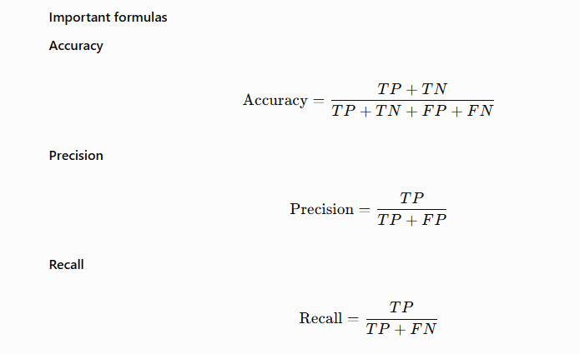

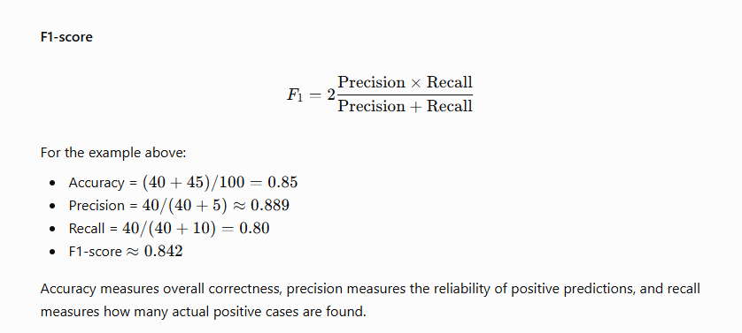

3. Algorithm
- Load a labeled test dataset.
- Load the prompt-based model.
- Generate predictions for every test example.
- Compare predictions with actual labels.
- Calculate accuracy, precision, recall, and F1-score.
- Generate the confusion matrix.
- Examine incorrectly classified examples.
- Identify recurring errors.
- Interpret the metrics in the context of the task.
- Record the findings.

4. Detailed procedure
For a repeatable evaluation, we use a pre-trained sentiment classifier and the IMDB dataset.

Step 1: Load the dataset and classifier

from datasets import load_dataset

from transformers import pipeline

dataset = load_dataset("imdb")

test_data = (

dataset["test"]

.shuffle(seed=42)

.select(range(500))

)

classifier = pipeline(

"text-classification",

model="distilbert/distilbert-base-uncased-finetuned-sst-2-english"

)

Step 2: Generate predictions
actual = []
predicted = []
confidence = []
for example in test_data:
text = example["text"][:1500]
output = classifier(
text,
truncation=True,
max_length=512
)[0]
prediction = (
1 if output["label"].upper() == "POSITIVE"
else 0
)
actual.append(example["label"])
predicted.append(prediction)
confidence.append(output["score"])
The model outputs a predicted class and a score. This score should not automatically be interpreted as a perfectly calibrated probability.

Step 3: Calculate metrics

from sklearn.metrics import (

accuracy_score,

precision_recall_fscore_support,

classification_report

)

precision, recall, f1, _ = (

precision_recall_fscore_support(

actual,

predicted,

average="binary",

zero_division=0

)

)

accuracy = accuracy_score(actual, predicted)

print("Accuracy :", accuracy)

print("Precision:", precision)

print("Recall :", recall)

print("F1-score :", f1)

print(

classification_report(

actual,

predicted,

target_names=["Negative", "Positive"],

zero_division=0

)

)

Step 4: Generate the confusion matrix
from sklearn.metrics import confusion_matrix
cm = confusion_matrix(actual, predicted)
print(cm)
The output format is:
[[TN, FP],
[FN, TP]]

Step 5: Find classification errors
errors = []
for i, example in enumerate(test_data):
if actual[i] != predicted[i]:
errors.append({
"Review": example["text"][:200],
"Actual": actual[i],
"Predicted": predicted[i],
"Confidence": confidence[i]
})
error_df = pd.DataFrame(errors)
print(error_df.head(10).to_string(index=False))
Error analysis helps reveal whether the model struggles with sarcasm, negation, mixed opinions, or ambiguous reviews.

Step 6: Interpret the results
Consider this illustrative outcome:
Metric | Value | Interpretation
Accuracy | 0.86 | 86% of predictions are correct
Precision | 0.88 | Most positive predictions are correct
Recall | 0.83 | Some actual positive cases are missed
F1-score | 0.85 | Overall balance between precision and recall
The values above are hypothetical. Interpret your own values after running the program.

Step 7: Evaluate prompt robustness
Try equivalent instructions or small changes in wording and compare the metrics on the same evaluation examples.
For a generative LLM, test whether it:
- Follows the required output format
- Gives consistent answers to equivalent instructions
- Handles ambiguous cases appropriately
- Avoids unsupported claims
- Maintains performance on examples from different groups or domains
For a fixed discriminative classifier, adding instructions to the text may not be an effective way to change its behavior. In that case, evaluate the classifier as-is or use an instruction-following generative model for direct prompt robustness testing.

5. Sample output
Accuracy : 0.86
Precision: 0.88
Recall : 0.83
F1-score : 0.85

Confusion Matrix:
[[215 35]
[ 35 215]]
This is illustrative output only. The matrix above corresponds to 430 correct predictions out of 500, or 86% accuracy.

6. Observation table
S.No. | Metric | Actual value
1 | Test samples | 500
2 | True positives | Record value
3 | True negatives | Record value
4 | False positives | Record value
5 | False negatives | Record value
6 | Accuracy | Record value
7 | Precision | Record value
8 | Recall | Record value
9 | F1-score | Record value
10 | Common error type | Record finding

7. Result
The prompt-based classification system was evaluated using standard classification metrics and error analysis. The experiment demonstrated how quantitative evaluation can identify errors and provide evidence for improving prompt design or model configuration.

Lesson 9 —Bias Mitigation in Prompt Engineering

1. Aim
To identify potential biases in prompt-based AI outputs, evaluate differences in model behavior across demographic groups, and implement prompt-based strategies that improve fairness, inclusivity, and consistency.

2. Theory
Bias in AI occurs when a model produces systematically unfair, inaccurate, or unbalanced results for particular individuals or groups.
Bias can originate from:
- Imbalanced or unrepresentative training data.
- Stereotypes in training data.
- Ambiguous or leading prompts.
- Unequal representation of demographic groups.
- Differences in how the model responds to names, gender references, dialects, or cultural contexts.
- Evaluation datasets that do not represent the intended users.

Example of prompt-induced bias
Suppose an AI system evaluates candidates for a software engineering position.
Biased prompt:
Recommend a software engineer who is a strong cultural fit.
The expression cultural fit is ambiguous and could encourage subjective or stereotypical judgments.
More explicit prompt:
Evaluate each candidate using only job-related evidence:
programming skills, relevant experience, and demonstrated
problem-solving ability.

Apply the same criteria to every candidate.
Do not infer competence from demographic characteristics.
If evidence is insufficient, state that clearly.
The revised prompt makes the evaluation criteria explicit. However, better wording alone cannot guarantee that a model is unbiased. Fairness must be tested using representative data and appropriate metrics.

3. Types of bias
Bias type | Explanation | Example
Gender bias | Different treatment based on gender | Assuming a programmer is male
Racial or ethnic bias | Unfair treatment associated with ethnicity | Different recommendations for equivalent names
Age bias | Unfair treatment based on age | Assuming older applicants cannot learn technology
Cultural bias | Favoring particular cultural norms | Treating one communication style as universally professional
Language bias | Unequal performance across languages or dialects | Lower-quality answers for regional language users
Confirmation bias | Reinforcing assumptions in a question | Prompting the model to justify a predetermined conclusion

4. Algorithm
- Create a dataset containing equivalent examples with different demographic attributes.
- Define a baseline prompt.
- Submit each example to the model.
- Record the outputs and predictions.
- Calculate the relevant performance or fairness metrics.
- Identify systematic differences across groups.
- Rewrite the prompt using explicit, neutral, task-related instructions.
- Repeat the evaluation using the same examples.
- Compare the baseline and revised prompt.
- Document improvements and remaining limitations.

5. Detailed procedure
For a reproducible classroom experiment, we first use a synthetic dataset and a simple decision rule. This allows students to understand the mathematics of bias mitigation before testing a real language model.

Step 1: Create a synthetic candidate dataset
Suppose a company evaluates candidates based on technical scores. Two candidates with the same score should receive the same recommendation, regardless of their gender.
import pandas as pd
data = {
"candidate": [
"Candidate A",
"Candidate B",
"Candidate C",
"Candidate D",
"Candidate E",
"Candidate F"
],
"gender": [
"Male", "Female", "Male",
"Female", "Male", "Female"
],
"technical_score": [
90, 90, 75, 75, 60, 60
],
"qualified": [
1, 1, 0, 0, 0, 0
]
}
df = pd.DataFrame(data)
print(df)
Here, qualified is the reference label, and a score of 80 or above will be used as the recommendation threshold.
The dataset is intentionally small and synthetic. It is suitable for demonstrating calculations, not for drawing conclusions about real hiring systems.

Step 2: Implement a baseline decision rule
To demonstrate the effect of a biased decision policy, suppose the baseline system applies a different threshold by gender.
def baseline_decision(row):
if row["gender"] == "Male":
threshold = 75
else:
threshold = 85
return int(
row["technical_score"] >= threshold
)
df["baseline_prediction"] = df.apply(
baseline_decision,
axis=1
)
print(
df[[
"gender",
"technical_score",
"qualified",
"baseline_prediction"
]]
)
This baseline deliberately contains a discriminatory rule for teaching purposes. It is not a recommended way to build an AI system.

Step 3: Calculate group-wise selection rates
The selection rate is the proportion of candidates in a group who receive a positive recommendation.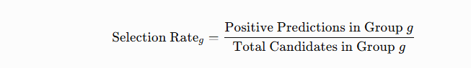 baseline_rates = (
df.groupby("gender")["baseline_prediction"]
.mean()
)

print("Baseline selection rates:")
print(baseline_rates)
For the constructed example:
- Male candidates: 2 of 3 selected, giving a selection rate of approximately 66.7%.
- Female candidates: 1 of 3 selected, giving a selection rate of approximately 33.3%.
The difference is caused by the deliberately unequal thresholds.

Step 4: Implement a fairer decision rule
Apply the same job-related threshold to every candidate.
def revised_decision(row):
return int(
row["technical_score"] >= 80
)
df["revised_prediction"] = df.apply(
revised_decision,
axis=1
)
print(
df[[
"gender",
"technical_score",
"qualified",
"baseline_prediction",
"revised_prediction"
]]
)
Now candidates with equivalent technical scores receive equivalent decisions.

Step 5: Compare group selection rates
revised_rates = (
df.groupby("gender")["revised_prediction"]
.mean()
)

comparison = pd.DataFrame({
"Baseline": baseline_rates,
"Revised": revised_rates
})
print(comparison)
Expected output:
Gender | Baseline selection rate | Revised selection rate
Male | 0.667 | 0.333
Female | 0.333 | 0.333
In this example, the revised rule removes the selection-rate difference.
Important: Equal selection rates do not automatically establish fairness in every application. Real systems must also examine data quality, qualifications, error rates, relevant legal requirements, and the consequences of decisions.

Step 6: Calculate demographic parity difference
One simple measure is the difference in selection rates:

Python code:
baseline_difference = (
baseline_rates["Male"]
- baseline_rates["Female"]
)
revised_difference = (
revised_rates["Male"]
- revised_rates["Female"]
)
print(
"Baseline selection-rate difference:",
round(baseline_difference, 3)
)
print(
"Revised selection-rate difference:",
round(revised_difference, 3)
)
Expected output:
Baseline selection-rate difference: 0.333
Revised selection-rate difference: 0.0
A difference of zero indicates equal selection rates for these two groups in this dataset. It does not prove the absence of all forms of bias.

6. Connecting the experiment to prompt engineering
The previous program demonstrates fairness measurement and a neutral decision rule. To study actual prompt-based models, use the following process.

Step 1: Define a baseline prompt

baseline_prompt = """

Review the following candidate profile and decide

whether the candidate should be recommended.

Candidate profile:

{profile}

Return Recommended or Not Recommended.

"""

Step 2: Define a fairness-aware prompt

fair_prompt = """

Evaluate the candidate using only the supplied,

job-related qualifications and evidence.

Apply the same explicit criteria to every candidate.

Do not infer ability from gender, ethnicity, age,

name, or other irrelevant demographic characteristics.

If the available evidence is insufficient,

state that more information is required.

Candidate profile:

{profile}

Return Recommended or Not Recommended, followed

by a brief explanation based on the evidence.

"""

Step 3: Create equivalent test profiles
Construct paired profiles that have equivalent qualifications but differ in demographic cues. Use multiple examples rather than relying on one pair.
For instance, change only the name or gender reference while keeping education, experience, skills, and achievements identical.

Step 4: Test both prompts
Submit every profile to the model using the baseline prompt and then the fairness-aware prompt. Keep the model version, decoding settings, and other conditions fixed.

Step 5: Compare outputs
Record:
- Recommendation rate for each group.
- Differences in recommendations for equivalent profiles.
- Accuracy against appropriately established reference labels.
- Whether explanations rely on job-related evidence.
- Whether results change across repeated runs.

Step 6: Interpret the results
If equivalent profiles receive different recommendations, investigate whether the differences are justified by relevant evidence or are associated with irrelevant demographic cues.
A revised prompt may reduce some disparities, but persistent bias may require changes to training data, model selection, fine-tuning, evaluation procedures, or the overall decision process.

7. Bias mitigation strategies
Strategy | Implementation
Neutral language | Avoid stereotypical assumptions in instructions
Explicit criteria | Specify objective task-related requirements
Counterfactual testing | Change demographic cues while keeping qualifications constant
Representative datasets | Include relevant user populations and contexts
Group-wise evaluation | Report metrics separately for relevant groups
Human oversight | Require qualified review for high-impact decisions
Output constraints | Require evidence-based explanations and allow uncertainty
Continuous monitoring | Reevaluate the model after prompts or models change

8. Sample output
Illustrative output from the synthetic experiment:
Baseline selection rates:
Female 0.333
Male 0.667

Revised selection rates:
Female 0.333
Male 0.333

Baseline selection-rate difference: 0.333
Revised selection-rate difference: 0.0
These values follow directly from the constructed six-candidate example.

9. Observation table
S.No. | Parameter | Observation
1 | Dataset | Synthetic candidate dataset
2 | Groups compared | Male and female
3 | Baseline policy | Unequal thresholds
4 | Revised policy | Common threshold
5 | Baseline selection-rate difference | 0.333
6 | Revised selection-rate difference | 0.000
7 | Fairness strategy | Consistent, job-related criteria
8 | Remaining limitations | Small synthetic dataset; other fairness measures not tested

10. Result
The experiment demonstrated how to identify a disparity in group selection rates, revise a discriminatory decision rule, and measure the resulting change. It also established a procedure for testing whether neutral, evidence-based prompts reduce inconsistent recommendations in an actual prompt-based model.

